**Assignment Part 1:**

**Individual report**

A Report Submitted in Partial Fulfillment of the Requirements for: Assignment 1 project

Submitted to: Swinburne University IT Department, Ms Nguyen Phuong Anh (Unit Convenor of COS10026.2)

By: Nguyen Manh Dung

Id:104181789

Date of Submission: 27/2/2023

1. **Introduction**

**1. Website Introduction**

In this project, we created a sneakers-selling website called The Shoesroom. The Shoesroom provided various types of shoes which help buyers easier to choose which is affordable shoes to buy.

**2. Objective of the report**

– This report's objective is to clarify the functionality of our website, its contents, and the thinking behind our decision to choose this particular product. We wish to deliver a webpage using HTML and CSS that satisfies the specifications of our assignment as well as go in-depth into some innovative contents code

**3. Outline of the report’s structure**

-This report will go through the following component:

**1. Website content**: Main content and purpose of each page, HTLM markups technical use, sitemap

**2. Website style:** Website presentation, CSS technical details, design screenshot

**3. Key feature:** Key and innovative features, enhancements

**4. My contribution:** My main contributions

**5. Conclusion:** Report summary, Improvements recommendation

1. **Website Content**

**-Site map**

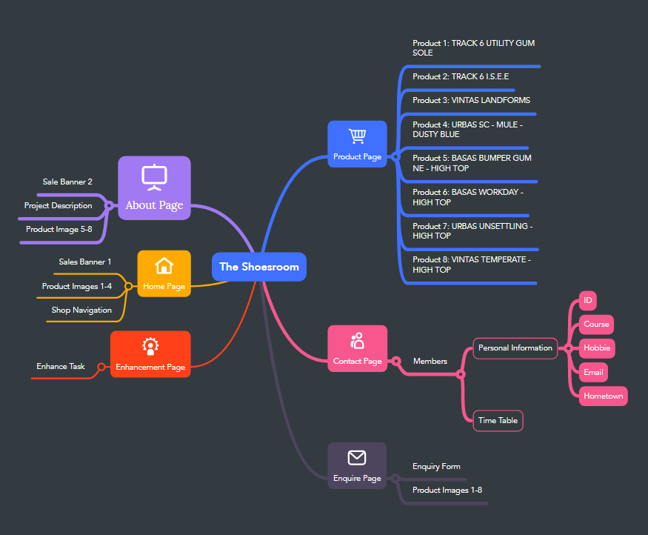

-The first webpage is a home page that is formed by index.html where we display a sizable banner to promote the most recent deals and promotions as well as briefly show some of the products. We self-edit the sales banner because we know that sending an eye-catching message or banner on the first page is crucial since it may have a significant impact on customers' purchasing decisions. We used a div named "adbox" and markup to insert our ‘jpg’ picture to place our sales banner. The shoes listed below are categorized as new arrivals, which might impact customers who are looking for the newest and most trendy shoes. As we use ul and li to arrange our product image in a horizontal list to make things convenient for our consumers, we use a hyperlink that connects to our shop page and places a prominent "shop here!" button. 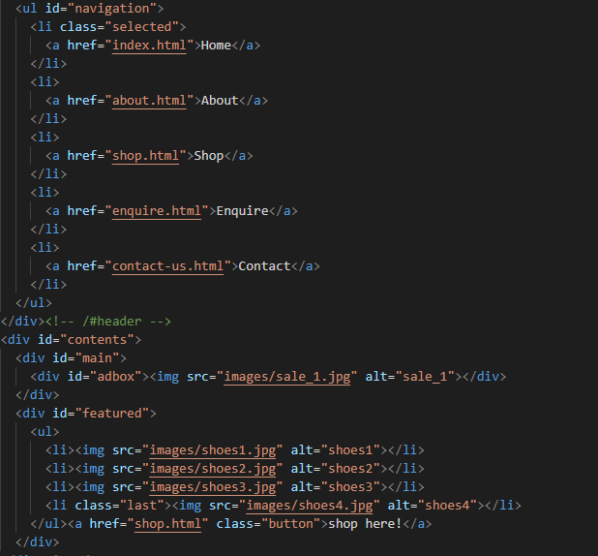

-The next website is about our project that is formed by index.html. It gives you more information about us. We want to convey the message to consumers as well as our business, and sales motto. We also provided our growth goals, sales plan, operational maxim, and requests to collaborate with additional sponsors. We also added our product photographs underneath to make the overview more specific like the home page. Our group created a section for content under the header "content" and we use the h1 and p markups for headings and text, respectively. Together with some of our gorgeous shoes, along with a hyperlink button similar to the one on our prior page. 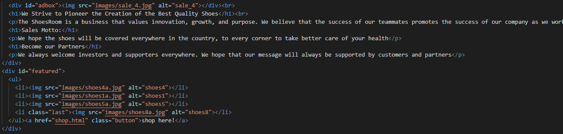

-The following page is our product page, we insert our sale quotes at the beginning of the page, and the reason to let buyers whenever buying or visiting our website will rest assured to trust our products. A self-edit banner is also included on this web to show the news which is different from the banner on other websites. 8 different shoes belong with amazing characteristics (size, colour, materials) will make buyers so much more convenient when choosing shoes. Comes with a shoe size change table which will guide consumers to choose their best size option. We also add an aside about shoe description to make the website look more proper, we use aside markup for this short message. 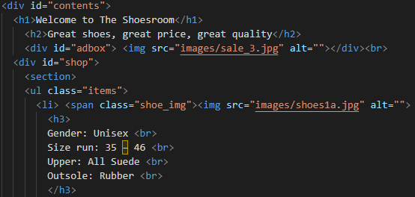 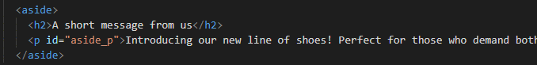

-The inquiry page is the next as required that is formed by enquire.html, in this page we created a form to get the consumers information that they wanted to know about our product. This is the most important page since it let the users communicate with the shop if we want to increase our sales income, we have to understand our customers This form, which we produced to just meets the requirements of this project, carefully complied with the guidelines and patterns established for each component, including the type, maximum, and particular patterns. We included a ‘submit’ and a ‘reset’ form button at the bottom of the form to test the data that was taken from the page on the Mercury form test website. 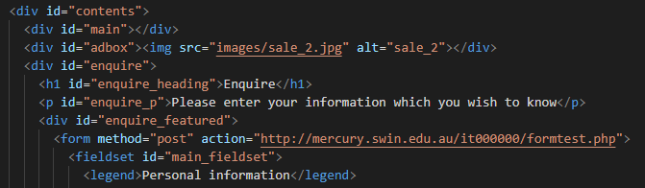

- We leave our contact information on the final page, which was generated using dl, the definition list, and has our profile images inside the "figure" markup. Our study schedules, which were prepared by table, tr, th, and td and together were put into a fieldset each individually to make it easier to look at, are included under our personal information. At the footer, we put a hyperlink to all the other pages, so it’s quite convenient for users.

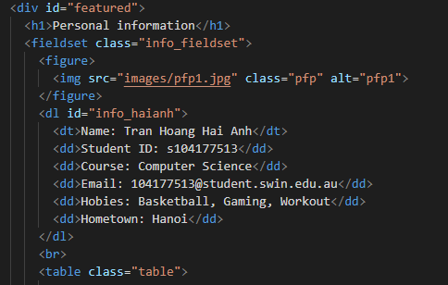

- The enhancement page, which is generated by enhancement.html, is the last. We highlight every improvement we've made to this website thus far on this page, including the moving background and the blurring image. With such improvements, we can guarantee that the website's user experience will improve because it is so simple and convenient.

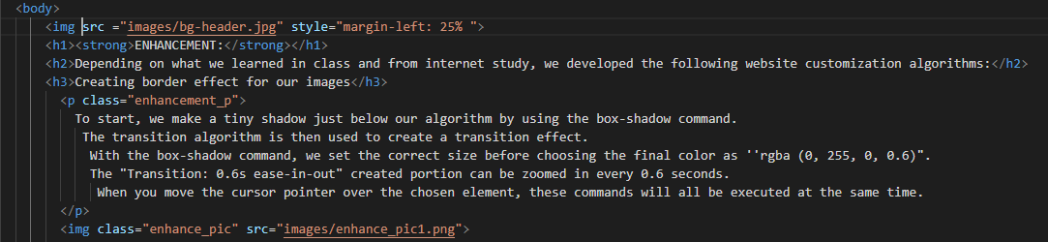

1. **Website Style**

**-** The website's pages all have the same layout, which enhances the user experience.

- The font family used across the website is the same, and each page has a consistent look.

- The same colour scheme has been used throughout to ensure that every page has a similar appearance and feel

-Our page idea is to centre all the features and information. In CSS files, we comment on every part of the code so that viewers can easily understand the code, and what it is used for, and also if we want to fix a particular page, we just need to scroll to that part and fix it which is much convenient and saving time.



Moreover, we set a different name for each animation so it’s easy to read and modify. Eg:

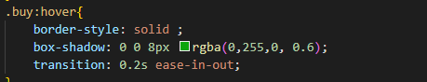

1. Overall, we create a moving background, which is our first enhancement. 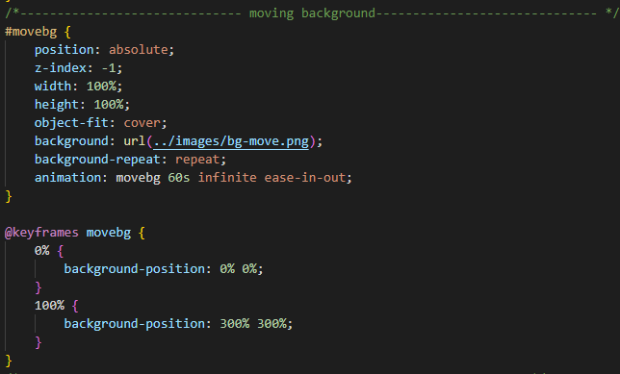

We name it “movebg” and the animation is infinite so we can see the background move continuously. We created a “@keyframe movebg” and set the background-position to 300% so the background able to move from left to right continuously.

Result: 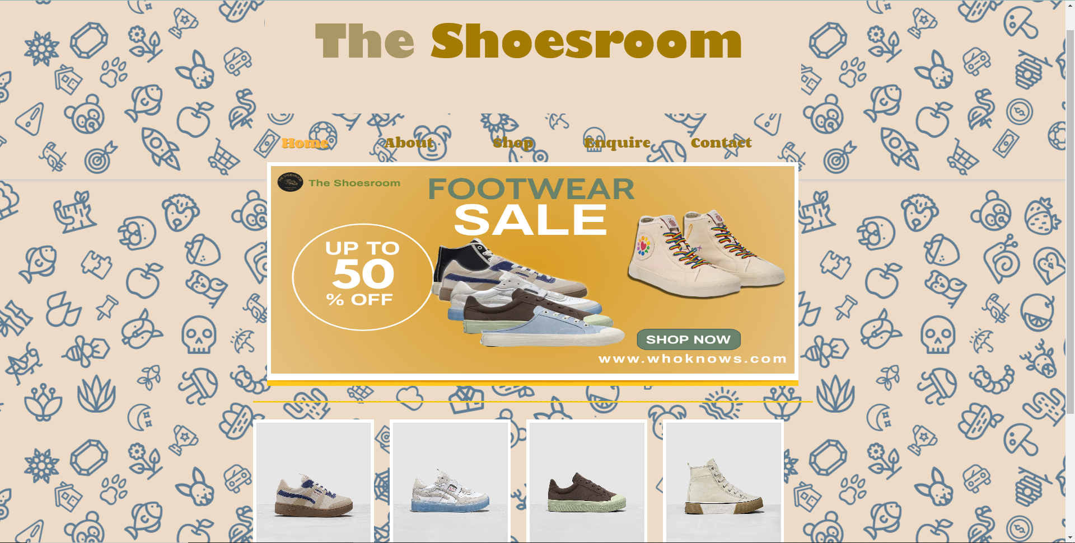

1. The algorithm that we employ for the animated navigation buttons on websites is seen in the image below. As you can see, we used text shadow to highlight the content at the top of each page. The decoration is then done using ‘text-decoration’. We applied the matching hue to both of these algorithms to increase their appeal. 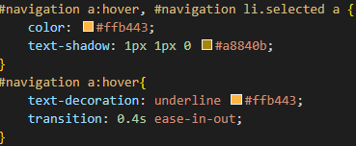

Result:



1. All of our images have a hover animation so when we hover the mouse over the image, its border will glow as colour ''rgba (0, 255, 0, 0.6)". 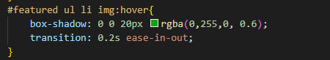 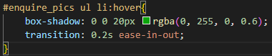

We first specify the appropriate size using the box-shadow command before deciding on the final colour, which is "rgba (0, 255, 0, 0.6)".The transition time is 0.2 sec to let us see the animation clearly and easily.

And this is the result:

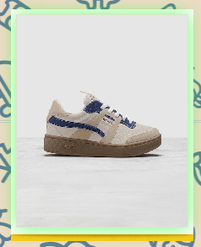 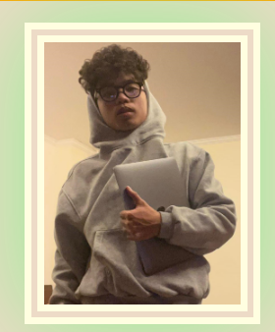

1. Those animation is also applied for the ‘buy’ button and navigation in the footer:

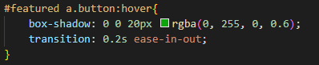 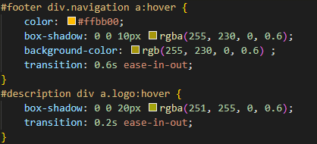

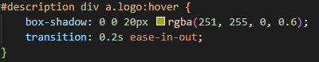

Result:

  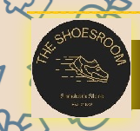

1. Regarding our aside message we fixed it information so that we can see aside despite scrolling the page. We use <tr><td> to make the shoe size table and <dl><dt><dd> to make the member’s information.

-Next, blurring the product and inserting product information is our second

enhancement

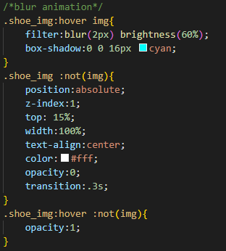

To help blur the product image, we employ the filter statement ( called the filter command). The size and opacity of the picture are determined by brightness and opacity, respectively. To make it simpler for customers to access the item, we do this so that we may later put product information directly into the photo frame. As previously indicated, we also employ box-shadow for decoration. The fundamental instructions that were covered in class, such as position, top, width, etc., are still applicable in the next two commands. Two new commands have been introduced to emphasize product details. The "z-index" command first establishes the layers' location (above or below previous layers). The second command, "opacity," controls how transparent a picture is.

Result:

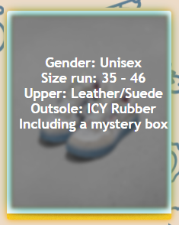

1. **Key Features**
2. **Moving background (1st enhancement):** This makes the website more entertaining and attractive. 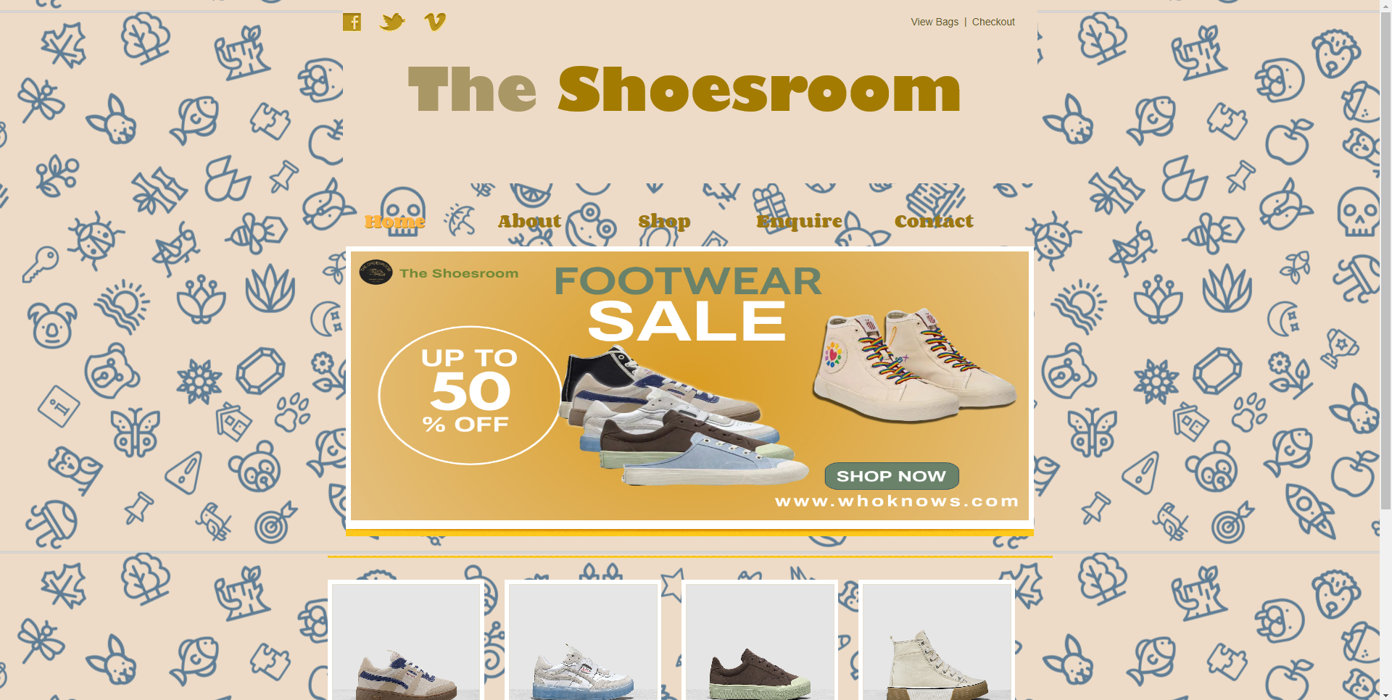
3. **The web has very beautiful and fresh colours:** we prefer to use pastel colours since it’s the common trend and most teens like it, the combination of various pastel colours makes the page look fresher than other types of colour.









1. **Real product image:** all of the product was by Ananas: a very famous Vietnamese shoe brand.

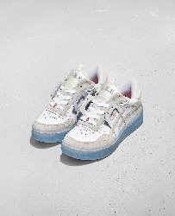 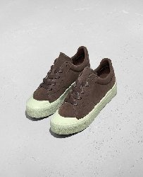

1. **Dynamic animation:** Hover animations, and blur animations have been carefully selected to include in the project, as shown above
2. **Blur animation and Insert information directly into the image (2nd enhancement):** make the product information looks cooler and more convenient, as shown above
3. **Self-edit banner:** The banner is completely made with the product attached to it, giving the buyer the feeling of wanting to buy the item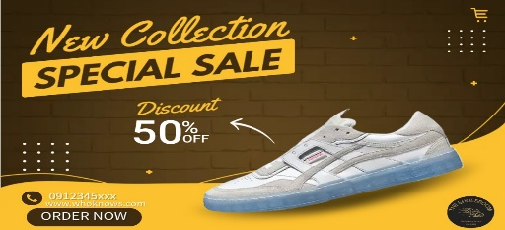 
4. **Your contribution**

**-**I’m in charge of the design and content of the Home page and Product page. To handle these pages, I planned all my idea into a paper, drew them and noted all the CSS animations, and colours I need to make them eye-catching and good-looking. Nike and Adidas web pages are where I developed my idea since it is my favourite shoe brands. I’m also the person to edit the sales banner and page background as well as choosing a suitable colour to make it not only simplest but also easy to see). After finished it all, I am responsible for developing page decoration and fixing the bug when we validate our CSS and HTML pages at <https://validator.w3.org/#validate_by_upload>

1. **Conclusion**

In conclusion, this report has covered every element of our website, and all fundamental needs, as well as enhancements, have been shown and well discussed. We believe that in the future the website will be improved in a more precise way, as well as improving some features such as adding to cart and product checkout.